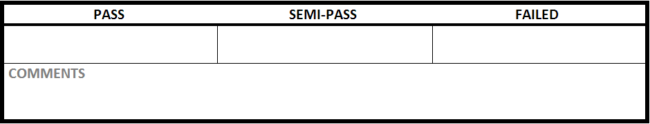

|  |  |
| --- | --- |
| Test Case #:LGN1.1 | Test Case Name:Login |
| System: Rec Warehouse | Subsystem:Login |
| Designed by: Rec Team | Design Date: October 2013 |
| Executed by: | Execution Date: |

|  |
| --- |
| Short Description: Login in with correct information |

|  |
| --- |
| Preconditions: At the login screen |

|  |  |  |  |  |
| --- | --- | --- | --- | --- |
| Step | Action | Expected System Response | Pass/Fail | Comment |
| 1 | enter ‘recreation’ into username | displays recreation in username |  |  |
| 2 | enter ‘1234’ into PIN | displays **** in password |  |  |
| 3 | click login | changes to the main systems home page: displays user logged in |  |  |

|  |
| --- |
| Post conditions: logged into the system, main menu is displayed |